**Introduction**

GLYCOGEN is a branched polysaccharide of glucose units linked by α- 1,4 glycosidic bonds and α-1,6 glycosidic bonds. It is stored primarily in the liver and muscle, and forms an energy reserve that can be quickly mobilized to meet a sudden need for glucose. The most common glycogen metabolism disorder is found in diabetes, in which, due to abnormal amounts of insulin, liver glycogen can be abnormally accumulated or depleted. Genetic glycogen storage diseases have been associated with various inborn errors of metabolism caused by deficiencies of enzymes necessary for glycogen synthesis or breakdown.

Simple, direct and automation-ready procedures for measuring glycogen concentrations find wide applications in research and drug discovery. LSBio’s glycogen assay uses a single Working Reagent that combines the enzymatic break down of glycogen and the detection of glucose in one step. The color intensity of the reaction product at 570nm or fluorescence intensity at λex/em = 530/585 nm is directly proportional to the glycogen concentration in the sample. This simple convenient assay is carried out at room temperature and takes only 30 min.

**Key Features**

* Use as little as 10 μL samples. Linear detection range: 2 to 200 μg/mL glycogen for colorimetric assays and 0.2 to 20 μg/mL for fluorometric assays.

**Components**

|  |  |
| --- | --- |
| **Component** | **K183-100** |
| **100 Tests** |
| Assay Buffer | 12 mL |
| Enzyme A | Dried |
| Enzyme B | 120 µL |
| Dye Reagent | 120 µL |
| Standard (50 mg/mL) | 50 μL |

**Materials Not Supplied**

Pipetting devices, centrifuge tubes, clear flat-bottom uncoated 96-well Plates, optical density plate reader; black flat bottom uncoated 96-well plates, fluorescence plate reader.

**Storage**

The kit is shipped on ice. Store all kit components at -20 °C.

**Assay Procedure**

**Reagent Preparation**

Reconstitute Enzyme A by adding 120 μL Assay Buffer to the Enzyme A tube. Make sure Enzyme A is fully dissolved by pipetting up and down. Store reconstituted Enzyme A at -20°C and use within 1 month.

**Sample Preparation**

Samples can be prepared according to Murat & Serfaty (Clin Chem. 20:1576-1577, 1974). Briefly, homogenize tissue/cell sample in 25 mM citrate, pH 4.2, 2.5 g/L NaF on ice. Centrifuge 14,000 g for 5 min to remove debris, and use 10 μL clear supernatant for the assay.

**Colorimetric Procedure**

1. Equilibrate all components to room temperature. During experiment, keep thawed enzymes in a refrigerator or on ice.
2. Standards and samples: Dilute standard by mixing 5 μL Standard with 1.245 mL dH2O to give 200 μg/mL standard. Dilute standard in dH2O as follows.

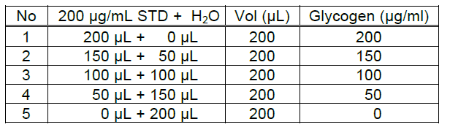

Transfer 10 μL standard and samples into separate wells of a clear flat-bottom microplate. If the sample contains glucose, transfer an additional 10 μL sample to another well for the Sample Blank.

1. Working Reagent. For each reaction well, mix 90 μL Assay Buffer, 1 μL Enzyme A, 1 μL Enzyme B and 1 μL Dye Reagent in a clean tube. For Sample Blank wells, prepare Blank Working Reagent by mixing 90 µL Assay Buffer, 1 µL Enzyme B, and 1 µL Dye Reagent (No Enzyme A). Transfer 90 µL Working Reagent into each Standard and Sample well. Transfer 90 μL Working Reagent into each reaction well. Tap plate to mix.
2. Incubate 30 min at room temperature. Read optical density at 570 nm (550-585 nm).

**Fluorometric Procedure**

For fluorometric assays, the linear detection range is 0.2 to 20 μg/mL glycogen. Follow steps 1-3 of the colorimetric procedure, but prepare 0, 5, 10, 15 and 20 μg/mL Standard and use a black flat-bottom microplate. Incubate 30 min at room temperature and read fluorescence at λex = 530 nm and λem = 585 nm.

**Calculations**

Subtract Blank reading (OD570nm or fluorescence intensity) from the standard reading values and plot the ΔOD or ΔF against standard concentrations. Determine the slope and calculate the glycogen concentration of the sample.

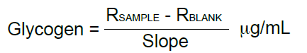

RSAMPLE and RBLANK are the OD570nm or fluorescence intensity values of the sample and blank (water, or sample blank, see below).

**Sample Data**

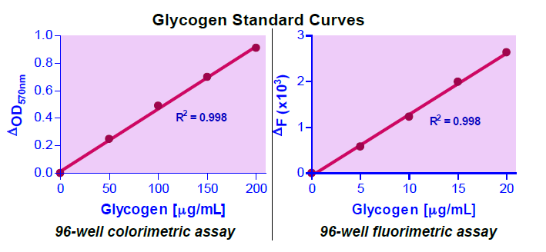

Version: V.08.09.2018